
Department | FED
Subject | DSA-2
Academic Year
Faculty Name | G. Mamatha
Student Name | K. Hemanth
Roll Number | 2520030230
Branch | CSE
Course Outcome

Case Study Topic: Wikipedia hyperlink graph
Work Done Summary:
In this case study, we analyzed how Apache Kafka retrieves records efficiently using a sparse offset index in a log-compacted topic. The system stores key-value records in an append-only log, where older records with the same key are periodically removed, retaining only the latest value. The requirement was to enable fast lookup of records by offset while minimizing memory usage.
We observed that Kafka uses a sparse index structure that maps logical offsets to physical byte positions. Instead of storing every offset, the index stores entries at fixed intervals, significantly reducing memory consumption. During lookup, Kafka performs a binary search on the index to find the closest offset less than or equal to the target, jumps to the corresponding position in the log, and then sequentially scans forward to locate the exact record.
.Implementation Details:
• • Created a log structure using an array/list
• Implemented a sparse index storing offset-position pairs
• Used binary search to locate nearest offset in index
• Simulated jump to log position using index entry
• Performed sequential scan to find exact record
• Counted steps to analyze performance

Result / Output:
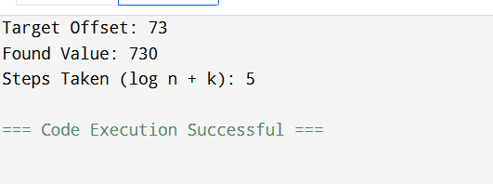
• BST is not suitable for real-time systems with sorted input
• AVL Tree is highly efficient due to self-balancing
• AVL ensures:
- Faster retrieval
- Reduced search time
- Better scalability

Time Complexity:
- Insertion: O (log n)
- Deletion: O (log n)
- Search: O (log n)

GitHub Link: https://github.com/hemanthkasani25-web

